APPLICATION FOR FUNDING IN 2026
To
Humana people to People Italia
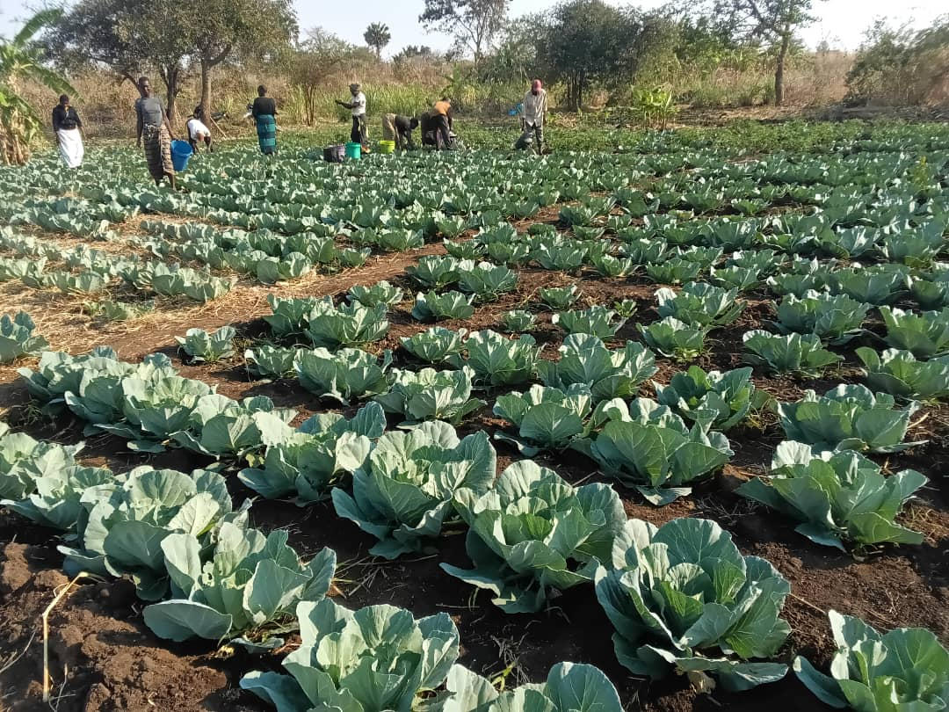
For
Farmers’ Clubs Balaka


DAPP MALAWI


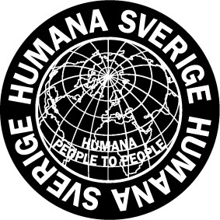
- Basic facts about the project
1 | Name of the project | Farmers’ Clubs Balaka
2 | Operation area | Balaka T/A Phalula and Traditional Authority (STA) Chanthunya
3 | Project Leader | Johnstone Chitupira
4 | Address | P.O. Box 2732, Blantyre- Malawi
5 | E-mail | jchitupira@dapp-malawi.org
6 | The project idea and who the project reaches | The Farmers’ Clubs Balaka project aims to empower 3,000 smallholder farmers in Balaka, Malawi (grouped in 100 farmers’ clubs). By promoting sustainable agricultural practices, enhancing access to markets, and strengthening land tenure rights, the project will improve food security, increase incomes, and reduce poverty.  The project will prioritize the needs of women, youth, and persons with disabilities, ensuring their equal participation and benefit. It will be implemented in collaboration with local partners, including DAPP, Malawi Council for Disability Affairs (MACODA).
7 | People at the Project | 1 Project Leader, Farming instructors, 1 Water technician, 1 M&E Officer, 1 Cross Cutting Officer, 1 Administrator, 1 Driver, 2 Security guards
8 | A brief history | The implementation commenced in January 2025 with recruitment of project staff and entry meetings namely; District Executive Committee (DEC), Area Development Committee (ADC) and Village Development Committee (VDC). The District Agricultural Extension Committee (DAEC) also approved the project's implementation while providing guidance on how to proceed. This project is funded by the Ministry for Foreign Affairs of Finland (MFA). The project will run from January 1, 2025, to March 31, 2028.

- Executive summary
The Farmers’ Clubs Balaka project aims to empower 3,000 smallholder farmers in Balaka by promoting sustainable agriculture, improving market access and protecting marginalized groups' rights. The project desires to enhance food security, increase incomes, and reduce poverty from 2025 to 2028. The second year of project implementation (2026) marks a shift from foundational setup to full-scale implementation of climate-resilient and inclusive development activities.

Key activities in 2026 include trainings in climate smart agriculture, small scale irrigation systems, village savings and loans associations, customary land laws and governance issues among cooperative members. The project also plans to practically train farmers on demonstration plots setup by each of the 100 clubs. The field officers will be responsible for daily operations of various club activities. Women, youth and people with disabilities will be included in the project activities to ensure inclusive delivery of project outcomes

As means of systematic monitoring and evaluation, the project set up expected results (realistic targets) to measure progress against primary and secondary indicators.

- Placing the project in its Context
The agriculture sector in Malawi employs more than 80 percent of the country ́s workforce, and it makes up to 36 percent of Malawi’s GDP and 90 percent of its export earnings (Ministry of Agriculture in Malawi, 2022). In recent years the sector –and thereby the lives and livelihoods of Malawi’s population –has become increasingly threatened by climate change induced hazards. These hazards include violent floods, high temperatures, unpredictable and extensive droughts as well as soil infertility. Smallholder farmers, who constitute the far majority of people involved with agriculture in Malawi, are particularly vulnerable in this context. Smallholder farmers in Balaka face challenges like low yields, limited market access, and poor soil quality. The Farmers’ Clubs project aims to address these issues by promoting sustainable agriculture, strengthening cooperatives, and empowering marginalized groups. By focusing on climate-smart practices, inclusive value chains, and land tenure rights, the project seeks to improve food security, increase incomes, and reduce poverty.
- The project’s plans for 2026
The project will carry out the following activities in 2026 (second year of project implementation)

Farmer Training in climate smart agriculture
The project will train 3,000 smallholder farmers in climate-smart agricultural practices, including crop rotation, intercropping, and organic farming.

Demonstration Plots
Establish 100 demonstration plots to showcase climate-smart practices. The project will also organize field days and farm visits to facilitate knowledge sharing and adoption of best practices.

Train smallholder farmers in affordable sustainable small-scale irrigation
3,000 Smallholder farmers grouped in100 clubs to be trained in affordable irrigation techniques with emphasis on the following locally available options;
- Conservation of water sources (e.g., covering with leaves to reduce evaporation)
- Use of watering cans and low-cost pumps
- Maintenance of small water bodies for year-round crop production
These trainings will be conducted in 100 irrigated demo plots, the water to be drawn from shallow wells and boreholes.

Training of Village Savings and Loans (VSL) Groups
All farmers’ clubs have a subset of Village Savings and Loans (VSL). The members to be trained on different topics, covering but not limited to:
- Importance of savings culture
- Entrepreneurship and financial literacy
- Effective fund management
The project to collaborate with government – trained Community-Based Trainers (CBTs) to ensure consistent messaging and ongoing support. CBTs continue to provide regular supervision due to their proximity to VSL groups as well for sustainability purposes.

Facilitate cooperative training
The project will in partnership with the Ministry of Trade and Industry train the 2 cooperatives adopted by the project. The trainings will be tailor – made to focus on leadership roles, governance, bulk buying, market linkages and collective marketing.

Facilitate Election of Customary Land Committees
The project in close collaboration with lands department officers under Balaka council, will facilitate the election of 17 customary land committees in Traditional Authorities Chanthunya (10) and Phalula (7). The committees will be formed at Group Village Head (GVH) level; there are 10 GVHs in Chanthunya and 7 GVHs in Phalula. The committees will oversee land management and governance to ensure equitable access and utilization. DAPP Project staff will be oriented on land issues including governance

Facilitate Procurement of Assistive Devices for Persons with Disabilities (PWDs)
The project through MACODA will Support the procurement of assistive devices for PWDs to enhance their mobility, accessibility, and participation in community activities. The devices will be selected based on individual needs, ensuring improved quality of life. The procurement will be done after a needs assessment.

- The expected results
 | Result Area/Activities | Target  Jan-Dec 2026
1 | Key (primary) Indicators
1.1 | Number of farmers trained in climate-smart agriculture | 3000
1.2 | Number of farmers trained in small scale irrigation technologies | 3000
1.3 | Number of farmers trained in Village Savings and Loans associations | 2000
1.4. | Number of demonstration plots established | 100
1.5 | Number of farmers with land certification | 500
2 | Other (secondary) indicators in support of objectives
2.1 | Number of farmers trained in nutrition-sensitive Agriculture and food processing (cooking demonstrations) | 3000
2.2 | Number of farmers trained in sustainable forest management | 500
2.3. | Number of sanitation campaigns e.g. tippy tap installation across households to promote handwashing and improve farmer health outcomes | 6
2.4 | Number of business plans developed and implemented | 20
2.5 | Number of women, youth and persons with disabilities participating in leadership roles | 100
2.6 | Number of customary land committees formed | 17

Means of Verification
The project will utilize a results matrix that includes specific impact, outcome, and output indicators, each with designated means of verification. The matrix will be fed from periodic program and M&E reports.

- Effects of the project
The following are the effects of the project on beneficiaries and their communities:
Poverty Reduction and Income Improvement:
The project aims to decrease the percentage of households living below the poverty line and increase income from agricultural production for target households through various forms of assistance.

Adoption of Sustainable Agricultural Practices:
The initiative will promote sustainable agricultural methods, focusing on women, youth, and persons with disabilities, leading to better land management practices and higher average yields.

Enhanced Market Access and Value Chain Participation:
Smallholder farmers will gain improved access to markets and participate in inclusive, gender-sensitive value chains, resulting in increased sales revenue and enhanced use of financial services.

Empowerment and Rights Protection:
The project emphasizes educating smallholder farmers about their rights related to food security, association, and health, particularly for vulnerable groups like women, youth, and persons with disabilities.

Capacity Building and Cooperative Development:
Establishing / adoption of cooperatives will enhance collaboration among farmers, improve collective bargaining power, and provide training to strengthen cooperative operations and governance.

- Budget in Main Figures
Exchange rate: 1 USD = 1800 in local currency  November 2025 |  | Budget figure  in USD
Income
1 | Granted partnerships | 154,956
2 | Other | 54,955
 | Total Income | 209,911
Expenses
1 | Human Resources  Program staff & supporting staff, including volunteers. Capacity building of staff. | 64,083
2 | General Operation of the Project  Building expenses, vehicles and transport, communication, information, insurance. | 32,575
3 | Program expenses  Training, workshops, meetings, materials, equipment, manuals, transport, monitoring and evaluation. | 92,599
4 | Administration& Audit  Audit expenses, staff & administration expenses for accounts. | 20,654
 | Total Expenses in USD | 209,911

